Task 2: Test log
Description of Test | Test Data | Expected Outcome | Actual Outcome | Comments and Intended Actions
Login Form Testing | Normal: valid username and password  Boundary: username/password with max length  Erroneous: invalid username/password | User successfully logs in.  Error message for invalid credentials | Successful log in  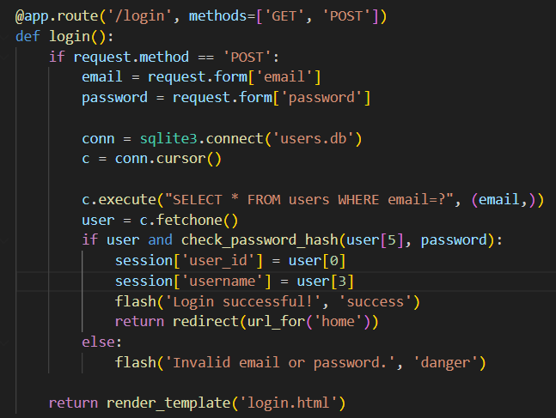   | Ensure error handling and edge cases are well-handled
Register Form Testing | Normal: valid details  Boundary: email with max length  Erroneous: invalid email format | New user is registered.  Error message for invalid data | Successful sign up  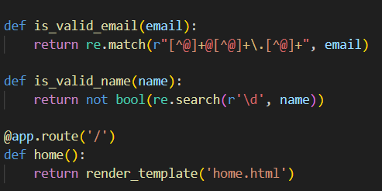  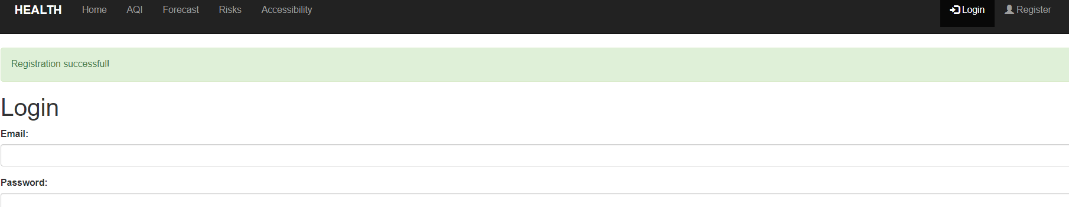 | Verify data validation and error messages
Session Testing | Normal: navigate through multiple pages after login | User remains logged in across pages | Pages remain to show the user logged and the session not ending  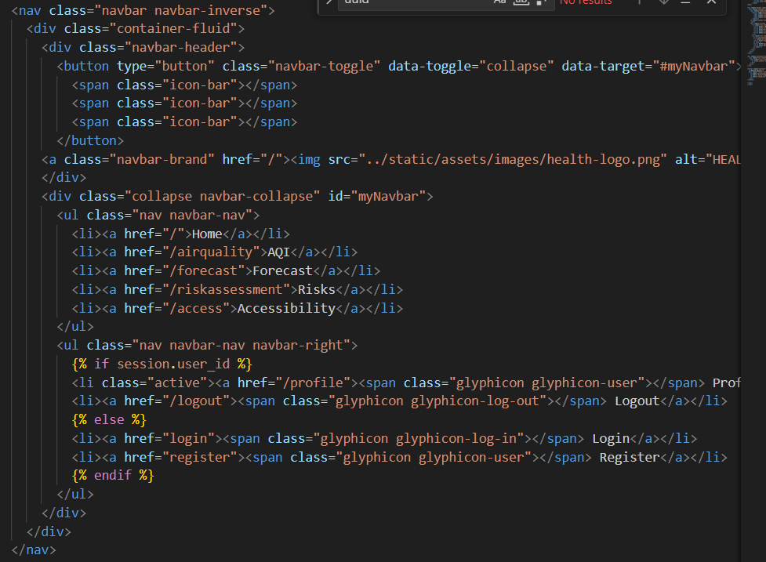  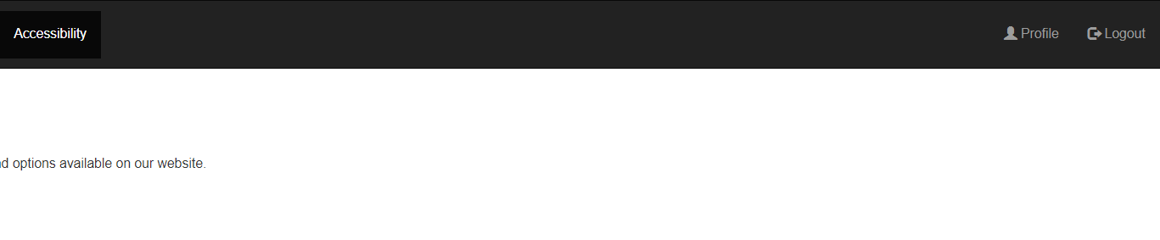 | Check session persistence and timeout
Profile Page Testing | Normal: access profile page  Boundary: profile with max information  Erroneous: corrupted profile data | Profile loads correctly.  Error message or fallback for corrupted data | Profile page loads correctly, shows user fields for updating account information.  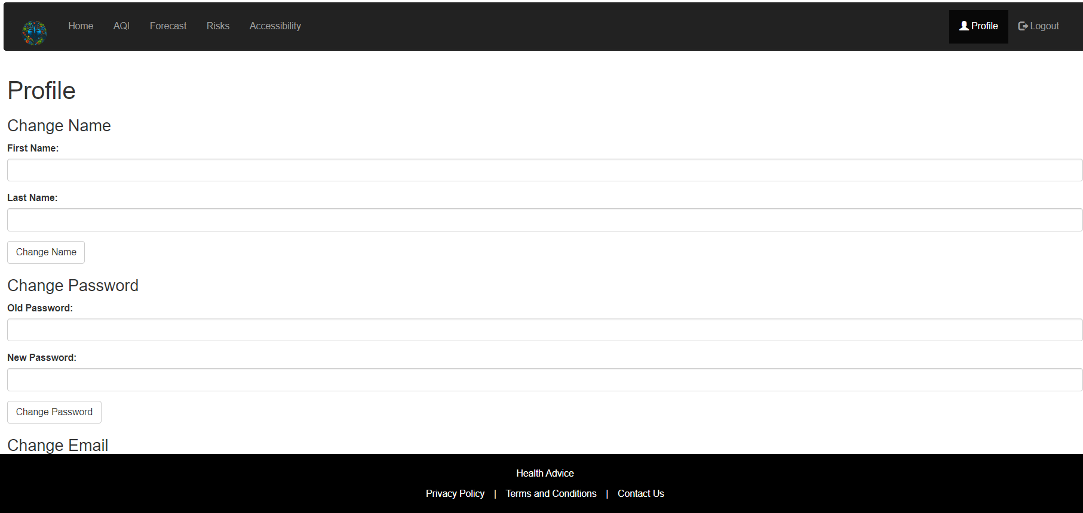 | Ensure data integrity and error handling
Updating Username | Normal: valid new username  Boundary: username with max length  Erroneous: empty username field | Username is updated successfully.  Error message for invalid username | Username updates successfully | Verify update functionality and error handling
Screen Scaling Test | Normal: various screen sizes | Website formats correctly  No UI/UX issues on smaller screens | Screen sizing and formatting on other devices works without issues.  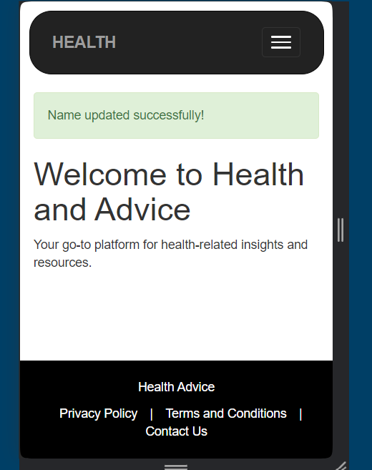 | Test responsiveness and adaptive design
Password Reset Functionality | Normal: valid email and name  Boundary: email with max length  Erroneous: invalid email format | Password reset allowed when email and name match details.  Error message for invalid email | Functions but not yet updating to the SQL database. Does not throw error. | Ensure security and proper error handling. Add the updating DB functionality.
Logout Functionality | Normal: logged-in user logs out | User is successfully logged out and redirected to login page | Successfully ends session and logs user out, returns to showing log in and register button. | Verify session termination and redirection
Form Validation | Normal: all fields filled correctly  Boundary: fields with max length  Erroneous: empty or invalid fields | Form submission is successful.  Error message for invalid data | Form correctly displays error messages for mis filled forms and when filled correctly submits the user’s information. | Test client-side and server-side validation
Browser Compatibility | Normal: different browsers (Chrome, Firefox, Edge) | Website displays and functions correctly on all major browsers | Runs and works on different browsers without issue. | Ensure cross-browser compatibility
Accessibility Testing | Normal: use screen reader  Boundary: colour contrast check | Website is accessible to users with disabilities | Not yet tested functionality for screen readers.  Colour contrast changing page and functions still to be implemented. | Ensure compliance with accessibility standards (e.g., WCAG)
Content Search Functionality | Normal: valid search query  Boundary: search query with max length  Erroneous: empty search query | Search results displayed.  Error message for empty query | Search bar yet to be implemented. (Optional feature I may add if I have time left over) | Verify search functionality and relevancy

